Congratulations! DataMinfo, Infraprint and Mersus win EIT Manufacturing’s start-up competition BoostUp! 2023 – IRELAND edition

The EIT Manufacturing start-up competition BoostUp! gives start-ups the opportunity to internationalise their business and access a large European network. The winners of the first Ireland-focused competition from EIT Manufacturing, supported by the European Institute of Innovation and Technology (EIT), a body of the European Union, were selected on 20 June: First prize went to DataMinfo, second prize to Infraprint, third prize to Mersus. The competition was co-organised by atim cluster.
Six finalists, all businesses from Ireland, presented their companies and their innovative approaches at Irish Manufacturing Research (IMR) in Mullingar. The audience consisted of guests from the Irish manufacturing industry and an expert jury, which selected three of the six as winners: DataMinfo, Infraprint and Mersus.
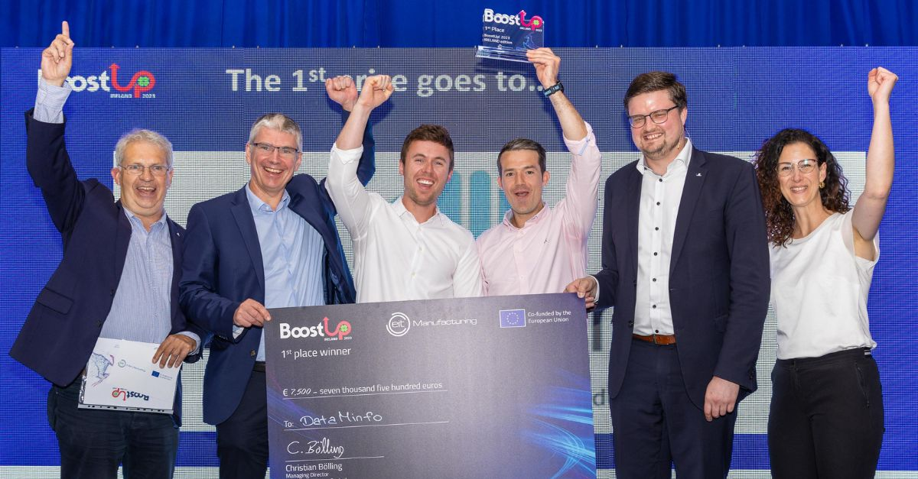
DataMinfo builds data driven solutions to help manufacturers increase plant capacity with a platform that can replace data complexity with actionable insights. Their off-the-shelf non-invasive machine monitoring system empowers their customers to address production bottlenecks in real time through live shop floor displays and automated decision making.
Figure 1: From left to right: Dr Wolfgang Kniejski, Senior Business Creation Manager EIT Manufacturing Central, Kevin Lenehan, Director Business Creation EIT Manufacturing, Paul Byrnes, CEO DataMInfo, Koen Jasper, COO DataMinfo, Dr Christian Bölling, Director EIT Manufacturing Central, Silvia Grätz, Business Creation Manager EIT Manufacturing Central

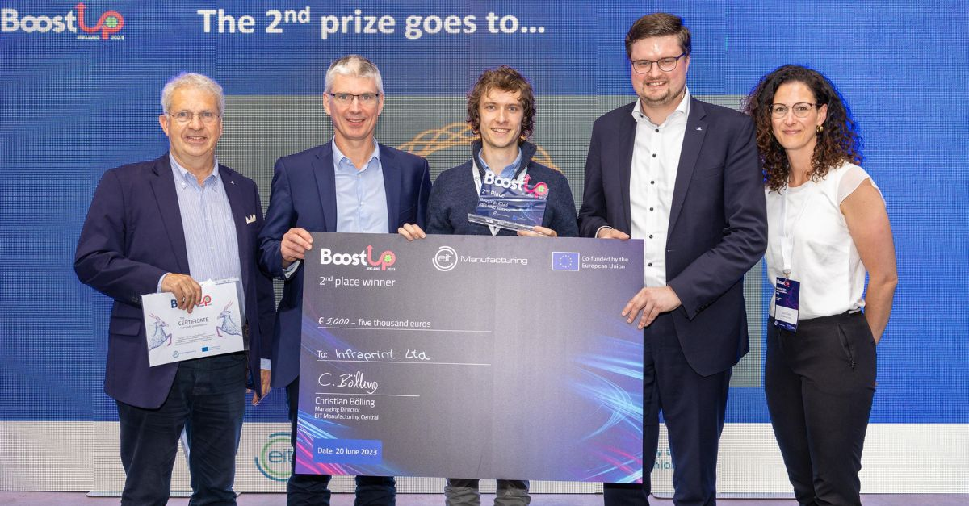
Infraprint Ltd is a contract manufacturer for advanced polymers and composites via Additive Manufacturing, utilising IP developed at University College Dublin and the experience of the founding team to produce high strength components for the aerospace and space sectors.
Figure 2: From left to right: Dr Wolfgang Kniejski, Senior Business Creation Manager EIT Manufacturing Central, Kevin Lenehan, Director Business Creation EIT Manufacturing, Dr Andrew Dickson, Founder, Executive & Technical Director Infraprint Ltd, Dr Christian Bölling, Director EIT Manufacturing Central, Silvia Grätz, Business Creation Manager EIT Manufacturing Central
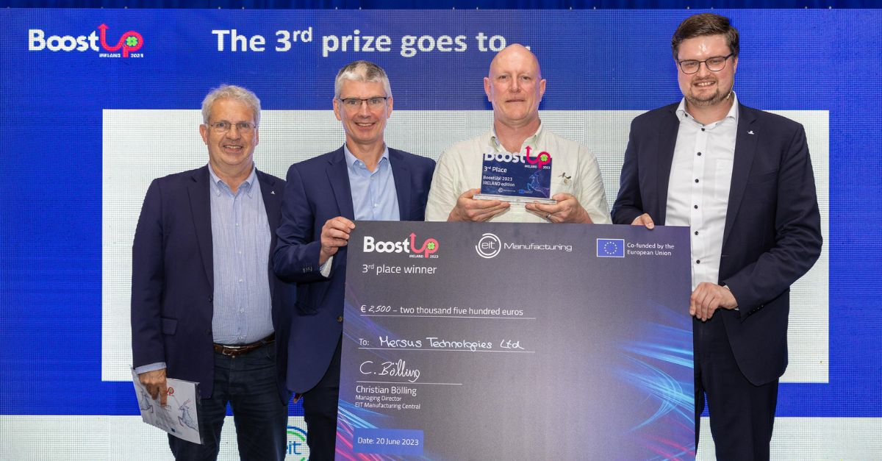
Mersus’ Avatar Academy platform is automating the creation of Virtual Reality experiences in a ‘Drag & Drop’ format. Award-winning graphics combine with unparalleled technical performance on hand-tracking mobile VR hardware. What is unique is how it captures the data generated allowing regulators to assess/trace trainee performance/progress. The approach makes it a ‘Fitbit’ for Industrial Training.
Figure 3: From left to right: Dr Wolfgang Kniejski, Senior Business Creation Manager EIT Manufacturing Central, Kevin Lenehan, Director Business Creation EIT Manufacturing, Geoffrey Allen, CEO Mersus, Dr Christian Bölling, Director EIT Manufacturing Central

With the award comes prize money of €7,500, €5,000 and €2,500 to support the businesses’ European go-to-market strategy as well as growth support for business development by the innovation network EIT Manufacturing. All finalists will additionally be invited to a matchmaking event in continental Europe which will bring them in contact with potential customers.
“Congratulations to all the teams, and specifically to the three winners,” said Dr Christian Bölling, Director EIT Manufacturing Central. “As an innovation network, one of our areas of activity is helping start-ups to thrive.” EIT Manufacturing Central’s Senior Business Creation Manager Dr Wolfgang Kniejski added: “The BoostUp! competition is great to enable businesses to internationalise and at the same time connect them to industry representatives who will be interested in their solutions. The competition is only the first step.”

Background
Ireland has established itself as a global hub for high-tech manufacturing, which contributes to job creation, exports and overall economic growth. EIT Manufacturing has long-standing ties with Ireland through their partnership with University College Dublin and Stryker. Since 2023, EIT Manufacturing has supported an innovation project involving the Irish companies Midland Steel, KUKA Ireland and Nightingale HQ, which is part of the EIT Manufacturing portfolio of supported start-ups. After the lockdown regulations were eased in 2022, collaboration with the atim cluster and IDEAM were cemented as network partnerships. Most recently the RDI Hub joined the network as collaboration partner.
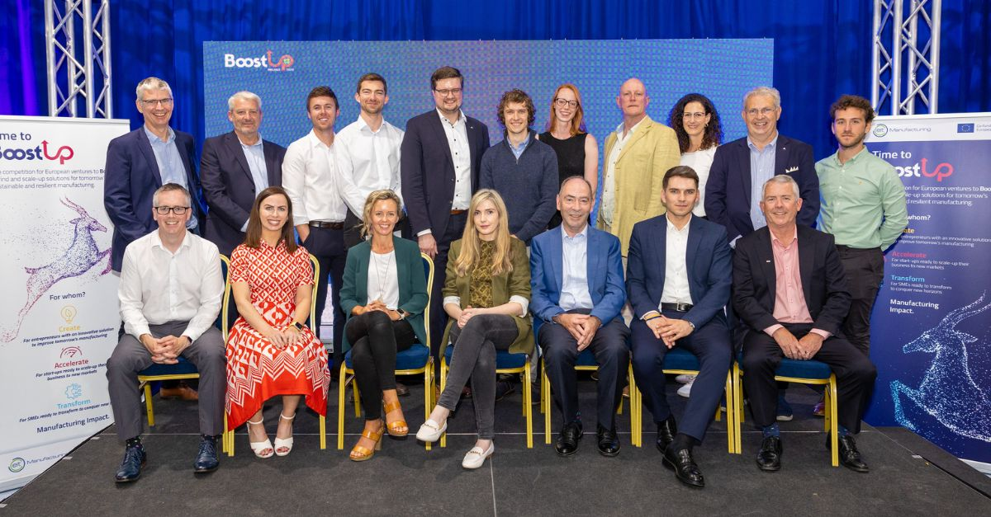
Figure 4: The group picture shows all finalists, organisers, jury members and speakers of the BoostUp! 2023 – IRELAND edition final in Mullingar.

Collaborative start-up competition
The start-up competition BoostUp! comes to Ireland for the first time. It is designed to give young companies to opportunity to internationalise and access a large European network. The competition is co-organised by the atim cluster, an Enterprise Ireland funded industry cluster, which supports Irish manufacturing companies’ by fostering increased productivity, driving competitiveness and supporting internationalisation activity through access to in-depth knowledge, services and collaboration-based initiatives.

Focus on Ireland
“In order to remain competitive into the future, Irish manufacturing companies, big and small, need to adapt technologies and solutions that will support them become more agile, efficient and competitive,” says Caitríona Mordan, atim Cluster Manager. “The competition is a great opportunity to showcase the fantastic spin-offs, early-stage and mature Irish start-ups that offer valuable solutions to manufacturing companies. It allows cluster members, who provide manufacturing technological solutions, to expand and scale their business across Europe. It is also fantastic for our manufacturing companies to learn what solutions are on offer and how their business can benefit from adopting them.”

Hosted by Irish Manufacturing Research
The competition was hosted by Irish Manufacturing Research (IMR) in Mullingar. Barry Kennedy, CEO of IMR stated that “start-ups play a vital role in supporting IMRs mission by bringing innovation, driving collaboration, prototyping, piloting new technologies, and attracting talent with the objective of stimulating economic growth, and disseminating knowledge”. He added: “Also, IMR recognises the importance that networking and networks themselves play, as it fosters collaboration, knowledge exchange, partnerships among researchers, industry stakeholders, and start-ups, enabling the growth of the manufacturing ecosystem. We are thus delighted to support EIT Manufacturing and its network partners with this competition as it brings industry experts, investors, entrepreneurs, and other stakeholders in the ecosystem together.”

About the organisers and the host
atim cluster
The atim cluster is an industry competitiveness cluster which brings together industry, academia and government to unlock new opportunities and deliver the vision of the Midlands in Ireland to become known internationally as a Centre of Excellence in Advanced Manufacturing. With over 66 industry members, atim is part of a national approach led by Enterprise Ireland through the Regional Technology Clustering Fund (RTCF) to support the growth of manufacturing SMEs and companies along the value chain.
The cluster’s mission is to enable manufacturing SMEs in the Midlands of Ireland, and across the country, take advantage of the opportunities presented by Industry 4.0, ensuring competitiveness, providing high value employment, and growing exports.
EIT Manufacturing
EIT Manufacturing is supported by the European Institute of Innovation and Technology (EIT), a body of the European Union, and it is one of nine innovation communities within EIT. EIT Manufacturing’s main goal is to bring European stakeholders focused on manufacturing together in innovation ecosystems that add unique value to European products, processes and services and inspire the creation of globally competitive and sustainable manufacturing. EIT Manufacturing brings together more than 80 members (universities, research institutes and business).
The European Institute of Innovation and Technology (EIT) strengthens Europe’s ability to innovate by powering solutions to pressing global challenges and by nurturing entrepreneurial talent to create sustainable growth and skilled jobs in Europe. The EIT is an EU body which is an integral part of Horizon Europe, the EU Framework Programme for Research and Innovation.
Irish Manufacturing Research
Irish Manufacturing Research provides start-ups and incubators with access to a pool of research expertise in various manufacturing domains. This expertise can range from advanced manufacturing technologies, process optimization, automation, robotics, additive manufacturing, and more. Start-ups can leverage this expertise to enhance their product development, refine their manufacturing processes, and gain an advance and sustainable competitive edge in the market. IMR possesses a state-of-the-art technological infrastructure and resources that start-ups may not have access to on their own. This includes pilot facilities, advanced machinery, testing equipment, and specialised software. By collaborating with Irish Manufacturing Research, start-ups can leverage these resources to prototype, test, and validate their products, minimising the capital expenditure required to set up their own facilities.

EIT Manufacturing — Making Innovation Happen!

Contact Details
Claudia Müller
Senior Communication Manager
EIT Manufacturing Central
communication.central@eitmanufacturing.eu
More information at www.eitmanufacturing.eu

